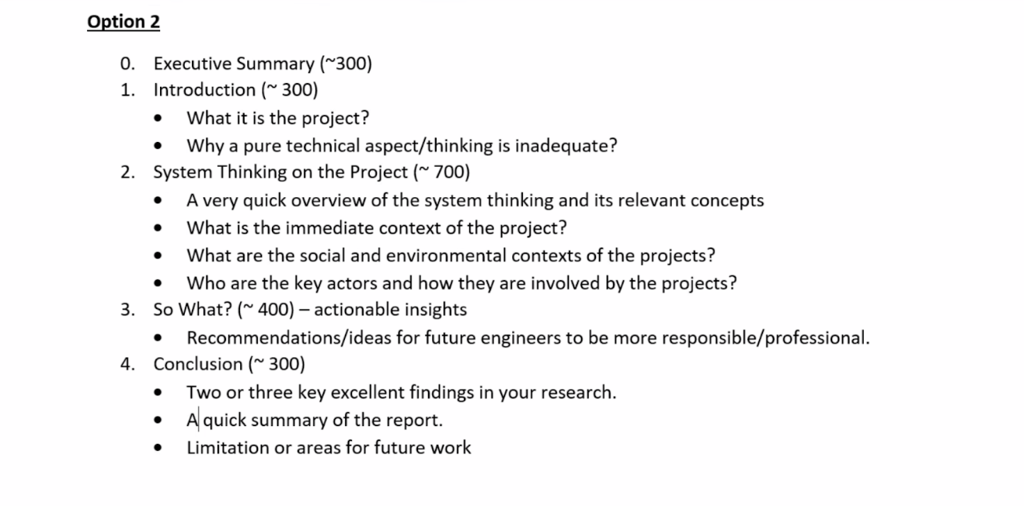

# What are the social and environmental contexts of the projects?

The social implications and environmental impacts of artificial intelligence and its applications are becoming the most compelling interest in our day-to-day life, related industries and research areas.

First of all, according to a research paper [1] by Alexa Hagerty and Igor Rubinov, AI has various social and environmental impacts depending on different geographical settings. On the other hand, people’s perceptions and understandings of AI are also influenced by their local cultural and social context.

Research from the U.S. shows that AI-driven applications such as DALL-E, have potential harm in accelerating social gaps and divides, as well as exacerbating social inequality, particularly among historically-marginalized groups. For example, AI researchers found that DALL-E leans toward generating images of white men by default, overly sexualized images of women, and reinforces racial stereotypes.

Last but not least, further research and action are more urgent and important than ever. The lack of high-quality on-the-ground research is accelerating social and environmental gaps worldwide. At this stage, it is essential and critical to figure out methodologies from AI and social aspects. To help mitigate DALL-E’s potential bias, OpenAI released its content policy [2] regarding DALL-E and other AI tools. As the policy mentioned, any image containing harassment, violence and sex elements is not allowed to create, upload or share. Besides, OpenAI also encourage people to respect others’ privacy and the allowable use of public resources.

# Who are the key actors and how they are involved in the projects?

(Stakeholders: OpenAI, AI researchers, tech companies using DALL-E, individual users)

A project life cycle [3] usually consists of project initiation, planning, execution, control and closure. Without exceptions, AI projects also have their life cycles and they are more sensitive to technical and non-technical factors. In this section, DALL-E’s key actors, as known as stakeholders, are divided into four groups:

1. The project owners and managers. In this case study, GPT-3 and DALL-E are originally authored by OpenAI, an AI company founded by Elon Musk and Sam Altman in 2018. DALL-E was initially released in January 2021. During the project life cycle, OpenAI is responsible for understanding the project, which includes technical factors and non-technical factors, such as R&D for the structure of neural networks, expected benefits of the company and other social concerns. Then, the owner needs to monitor DALL-E’s implementations, which include the common good of society and any potential misuse. At each stage, the owner needs to communicate with all the stakeholders periodically, ensuring the common interests of core stakeholders as well as maintaining the project scope.
2. Domain researchers and technical experts, especially in computer vision and natural language processing areas. Related researchers and experts are responsible for promoting innovation and sharing accessible AI knowledge with the public. In this case, DALL-E researchers have the responsibility of training their model with an unbiased dataset and designing test cases before the program lunch. Based on the research results, the project owner and its R&D team will be in charge of iteration in product development, until the product remains stable.
3. Project partners who are seeking AI solutions to specific domain problems. Project partners can be classified as organizations, such as governments [4] and business companies. For example, news companies like NPR are using DALL-E as a tool to generate images [5]. An online service company Stitch Fix uses DALL-E to visualize its products based on product characteristics [6], which will benefit from cost savings for the company. Project partners are an important part of the product chain, they promote the owner and researchers to update and develop the product, and offer end-to-end solutions for end-users.
4. All end-users of the project. The end-users of DALL-E include almost each one of us. For example, pictures on the news and social media are replaced by AI creations since the copyright and privacy concerns. On the other hand, people are using DALL-E applications to generate their pictures for personal use in YouTube videos, and training their own chatbot, such as Cortana by Microsoft. End users also provide feedback to the project owner and researchers, they benefit from DALL-E and other AI applications, but are also hurt by AI bias and malicious misuse.

# References

1. Hagerty, Alexa, and Igor Rubinov. "Global AI ethics: a review of the social impacts and ethical implications of artificial intelligence." arXiv preprint arXiv:1907.07892 (2019).
2. DALL·E. labs.openai.com/policies/content-policy. Accessed 9 Oct. 2022.
3. Manager, The Digital Project. “What Is the Project Life Cycle: The 5 Phases and Why It’s Important.” The Digital Project Manager, 16 June 2022, thedigitalprojectmanager.com/project-management-life-cycle.
4. Wirtz, Bernd W., Jan C. Weyerer, and Carolin Geyer. "Artificial intelligence and the public sector—applications and challenges." International Journal of Public Administration 42.7 (2019): 596-615.
5. “DALL-E Is Now Available to All. NPR Put It to Work.” NPR.org, 30 Sept. 2022, [www.npr.org/2022/09/30/1125976146/dall-e-art-ai-generator-npr](http://www.npr.org/2022/09/30/1125976146/dall-e-art-ai-generator-npr).
6. TechCrunch Is Part of the Yahoo Family of Brands. 9 Aug. 2022, techcrunch.com/2022/08/09/businesses-including-stitch-fix-are-already-experimenting-with-dall-e-2/?guccounter=1.